Day in the Life of the Hudson River 10/13/22
Coney Island Pier, Brooklyn, NY
RIVER MILE: -9.1
Salt Front: ~ RM76
IS 240 Andries Hudde JHS – Deborah Sarria
85 students (6th grade) & 58 adults
Latitude 40°34’N & Longitude – 73°59’W
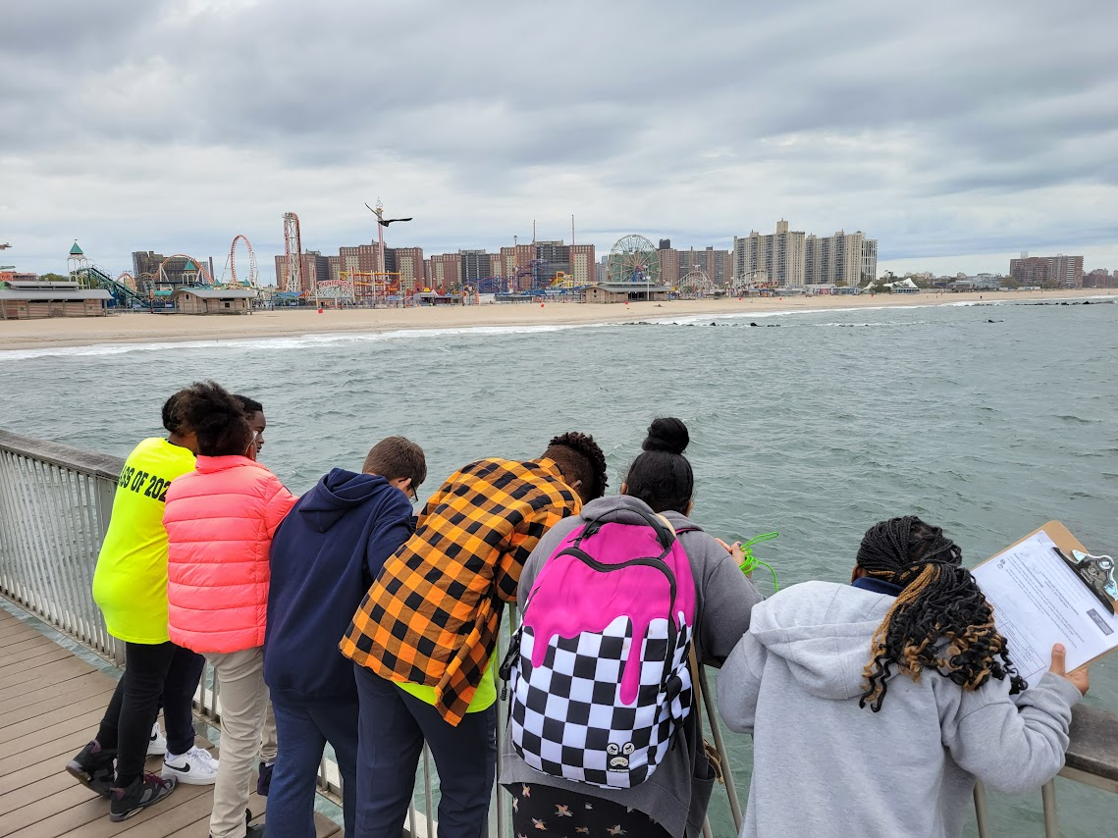 | 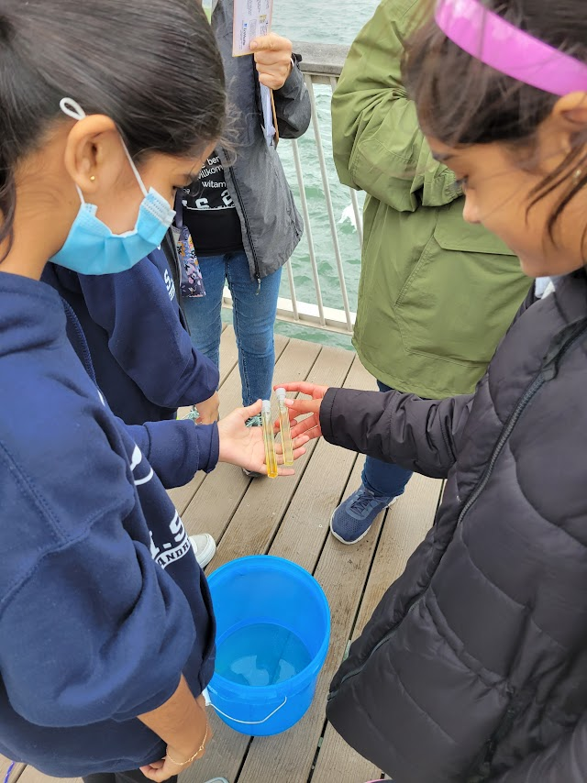 | 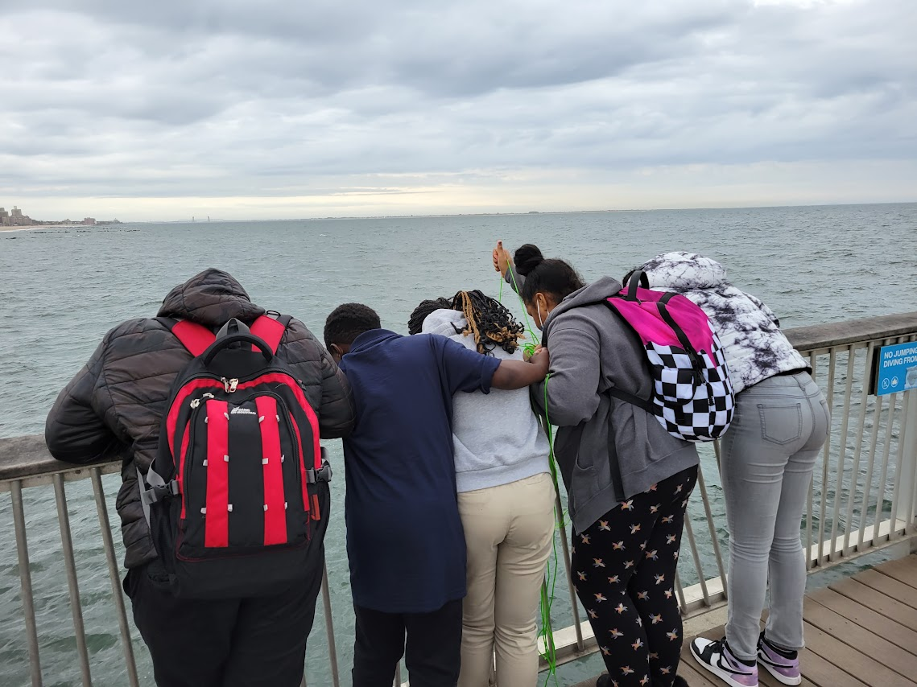

Location: Coney Island Pier, Brooklyn NY
Area: Halfway along the Coney Island Pier. The pier is located on the Reigelmann Boardwalk across from Parachute Jump.
Sampling Site: Pier and beach
Surrounding Land Uses: 5% Urban/Residential; 15% Industrial/Commerical; 80% Beach
Shoreline: sandy
Plants in the Water: No plants in the water
*NR = Not read/recorded
ITEM |  | Time |  | Reading |  |  |  | Comments
Physical
Air Temperature- |  | 12:11 PM  12:22 PM |  | 19°C  18.9°C |  |  | 66.2°F  66°F
Wind Speed: |  | 11:30 AM |  | Anemometer  5.8 mph |  |  | Beaufort  2 | Direction
Weather today |  | 11:30 AM |  | >75% cloud cover |  |  | On/Off Drizzle
Weather the past 3 days: |  | Cool and dry, started to rain on and off in the morning
Tides- |  | Time |  | Rising, Falling, Unchanged |  |  | Water Height (cm)
 |  | 11:39 AM-12:00 PM |  | Falling |  |  | 435 cm  460 cm | * Measurements from dock to water surface
Current- NR |  | Time |  | Cm/sec |  | Knots | North/South | Ebb/Flood/Still
Water Temperature- |  | 11:46 AM  12:08 PM |  | 17.2°C  17.1°C
Turbidity- Long Sight Tube (120 cm) |  | 12:18 pm |  | >120 cm
Chemical
Salinity-Hydrometer |  | 11:40 AM |  | 27.5 ppt
Standardized Salinity – Refractometer |  | 12:00 PM |  | 30,000 ppm
DO – Meter/Probe |  | Time  11:46 AM  12:08 PM |  | Temp  17.2°C  17.1°C |  |  | mg/L DO  9.68  9.15 | % saturation  100%  95%
pH – Color Match Kit |  | 11:52 AM  12:20 PM |  | 7  7
Nitrates- NR
Phosphates- NR
Alkalinity- NR
Biological-
Fish – Local Fisherman |  | Number |  | Name |  |  | Length of longest | Length of smallest
12:00 PM |  | 1 |  | Atlantic Menhaden
Fish Totals |  | TOTAL:1 |  | Diversity: 1
Macroinvertebrates |  | Number |  | Name |  |  | Length of longest | Length of smallest
Macroinvertebrate Totals |  | TOTAL: 0 |  | Diversity:0
Sediment Core - NA
Length NR | H2S smell |  | Oxid Top |  | Oil |  | Grain Size | Other Features
Boats-
 | Time |  | Name |  | Color |  | North/Southbound | Light/Loaded
Commercial | 11:54 AM  11:54 AM |  | CMaGGM Cargo Ship  Rockaway Ferry |  | White, Red & Blue  White, Black & Blue |  | Southbound  Westbound | Loaded  NR
Recreational | 11:54 AM |  | Sail Boat |  | NR |  | Westbound | NR

